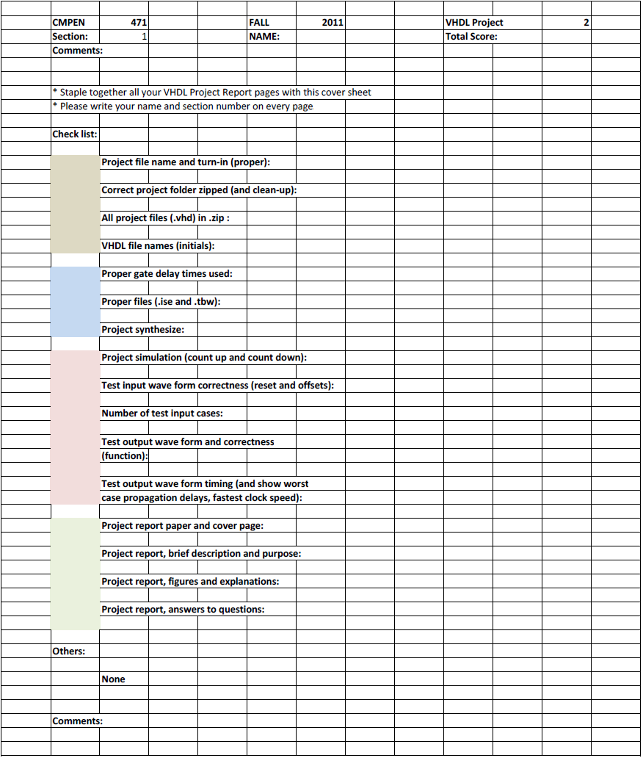
Erik Arfvidson
7

Erik Arfvidson
12/6/2012
Lab7

Project Report7

Purpose and Description

Design, implement, simulate, and debug a simple RISC microcontroller with 6 instructions and 2 addressing modes. Simply update project 6 by replacing the data register with dual port RAM. You will demonstrate the functionality of your design by writing simple Pulse-Width-Modulation (PWM) program. Simulate the microcontroller executing the program through the VHDL simulator.
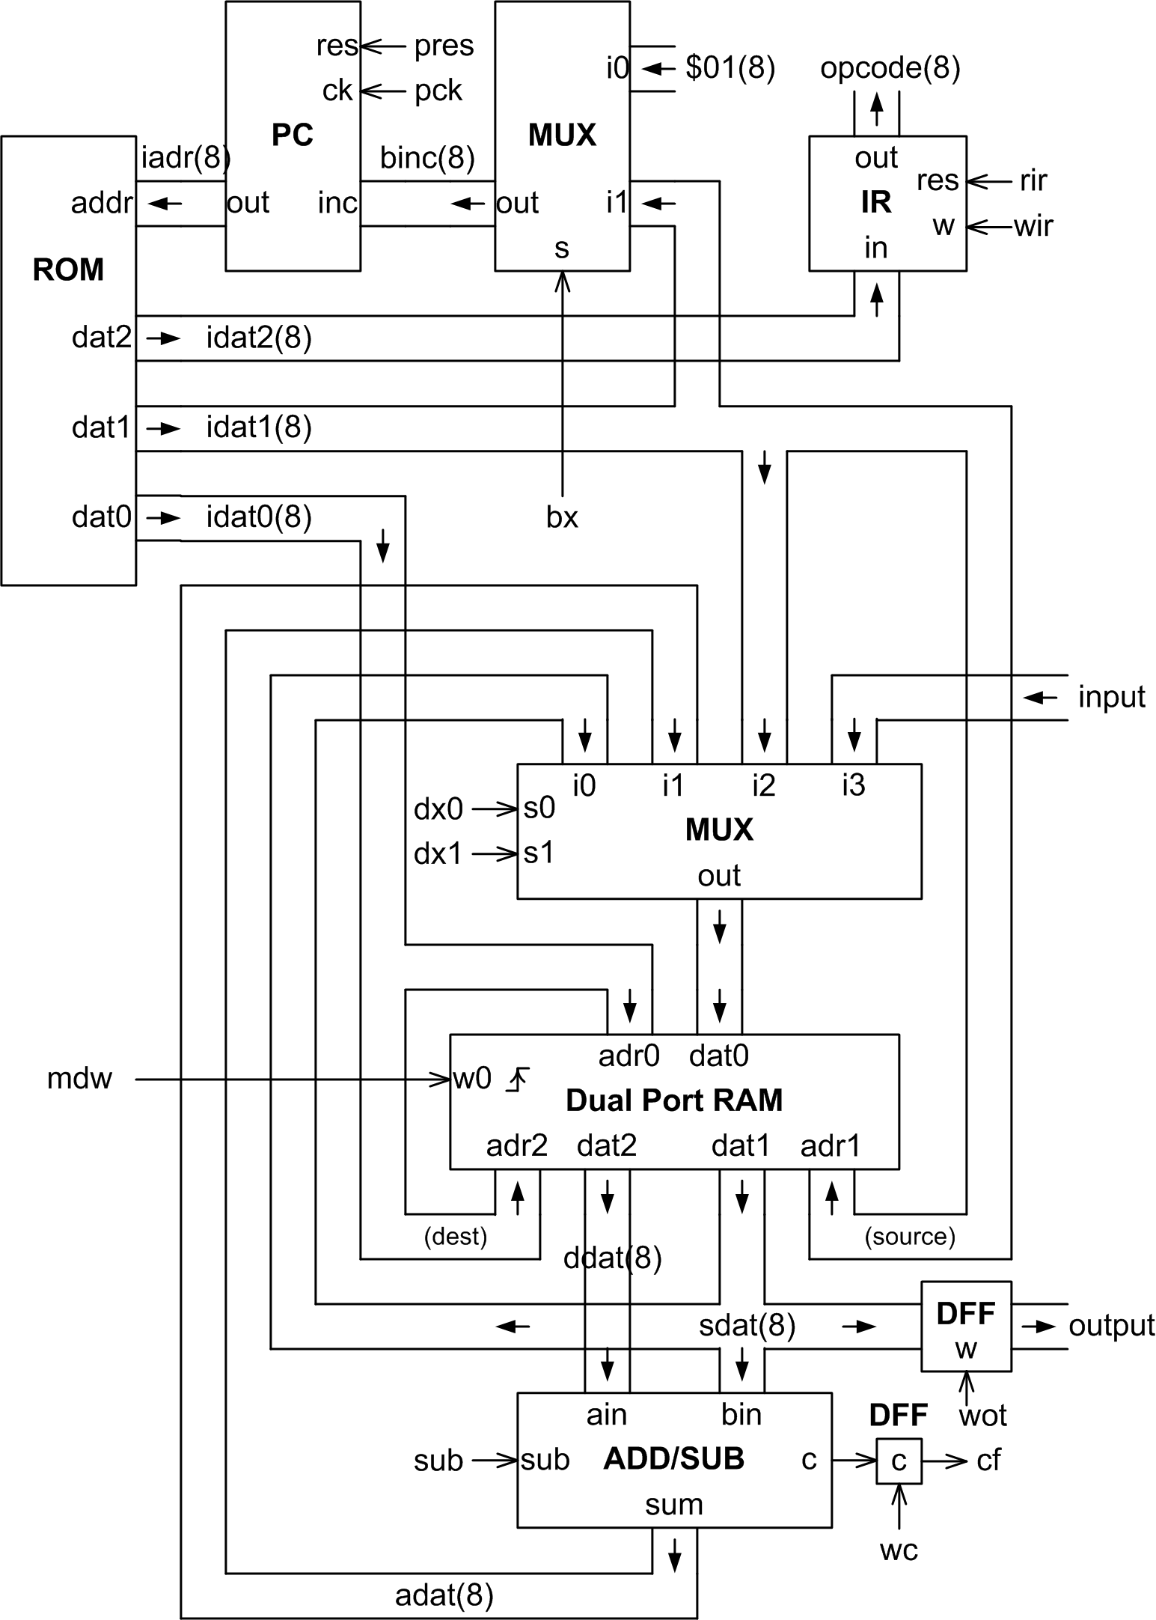

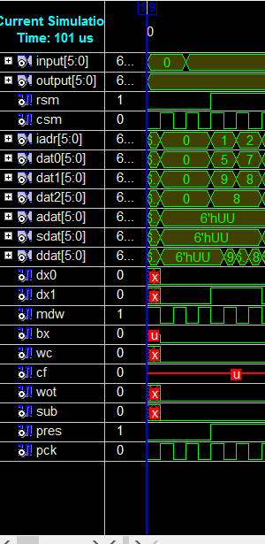
Simulations 1

The first command is a noop followed by write 9 to location 5 at the ram and write 8 to location 7

Simulation 2

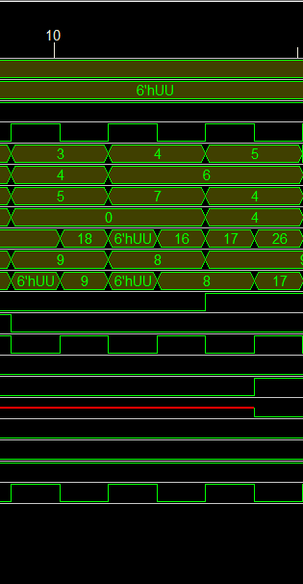

The first instruction in this segment is move contents of location 5 to location 4. The next instruction in the diagram is move location 7 data to location 6. We then preform an add instruction location 4 data to location 6 data and the store the value to location 6.

Simulation3

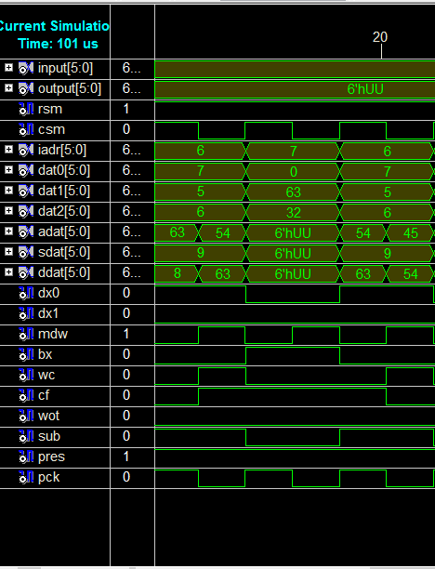
This Simulation is pretty Straight forward. The first instruction is subtract location 5 from location 7 and store to location 7. Then next is a branch instruction since it changes it branches to instruction 6 and it repeats the operation once. Finally we use the subtract instruction again so we subtract location 5 from location 7 and save it to location 7 .

Simulation4
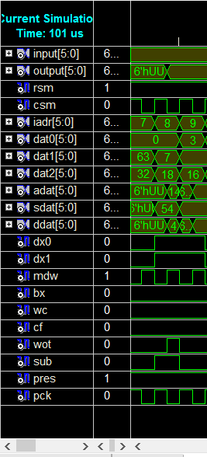
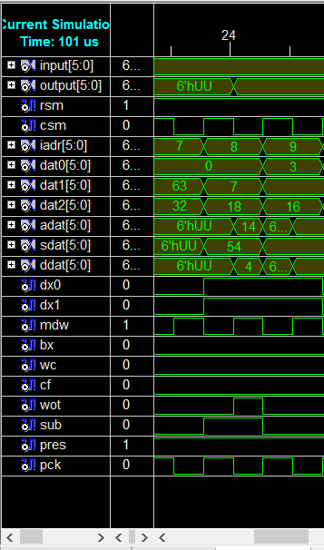
In this simulation we preform branch and it does not branch so it move to instruction 8. This instructions outputs location 7 data to the output port. Finally we preform store from the input port and store it to location 3 on the ram.

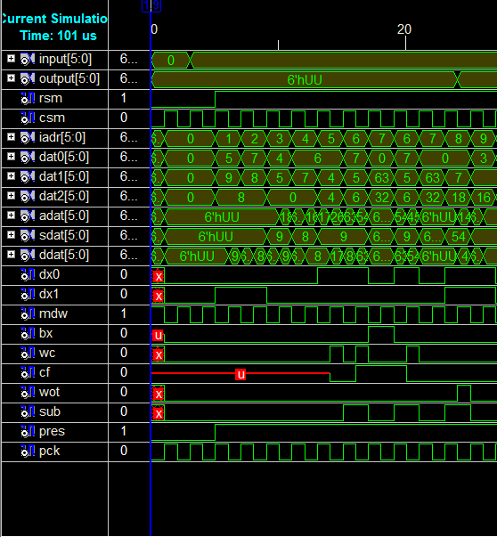
Testbench1

This is an image of the simulation of test bench1 that Runs program once and then reset and run it again.

TestBench2

NOTE: I was unable to get my pulse width modulation to fully work however I’m under the impression that the way that I coded my program did not apply to all the cases.

The maximum that achieved on my simulation was around 700Mhz before it Started to fail.

